Comparison OF
Different Models
(Brain Tumour Detection)

By Group- 254

Aspect | CNN Model | DNN Model | LSTM Model | CNN INCEPTION  Model | CNN INCEPTION ATTENTION  Model
Architecture | Optimized CNN | Fully connected Deep Neural Network (DNN) | LSTM-based sequence model | CNN with Inception modules | CNN with Attention Mechanism
Primary Use Case | Image classification with high accuracy | General classification tasks (not ideal for images) | Sequence-based data (e.g., time-series) | Image classification with multi-scale feature extraction | Image classification with attention focus
Feature Extraction | Strong (CNN architecture optimized for high feature retention) | Moderate (DNN lacks spatial feature extraction) | Weak (LSTM is better for sequences, not images) | Strong (Inception modules extract multi-scale features) | Excellent (Attention enhances focus on key features)
Computational Cost | Medium (Optimized CNN for efficiency) | Low (DNN is simpler but less effective for images) | Medium (LSTM requires sequential computation) | High (Inception modules are computationally expensive) | High (Due to attention layers)
Overfitting Risk | Low (Balanced model, avoids overfitting) | High (DNN lacks spatial understanding, overfits easily) | Medium (LSTMs tend to overfit on small datasets) | High (Inception modules increase parameters, risk of overfitting) | Low (Attention prevents overfitting by focusing on key areas)
Generalization Ability | High (Optimized for strong generalization) | Low (Struggles to generalize on image-based tasks) | Moderate (LSTM generalizes well but is data-sensitive) | Moderate (Can overfit to training data) | High (Attention helps models generalize better)
Confusion Matrix Performance | Well-separated (High accuracy and precision) | Some confusion (Lower performance) | Some misclassification | Well-separated (High accuracy) | Well-separated classes (High accuracy)
ROC Curve Performance | Excellent AUC (Best balance of precision and recall) | Lower AUC (DNN struggles with images) | Moderate | Good separation | Strong AUC (Very good classification ability)

Which Model is the Best?
Best Model: Best CNN_Model
- Balanced performance – Good accuracy without overfitting.
- Efficient – Strong feature extraction without excessive computation.
- Generalizes well – Handles unseen data better than over-complex models.
Alternative Choices
- If we prefer simplicity (but with lower performance) → DNN Model
- If we are dealing with sequence-based data → LSTM Model
- If we want multi-scale image feature extraction → CNN + INCEPTION
- If we need the most accurate but can handle high computation →
CNN + INCEPTION + ATTENTION

Models Used:
- CNN Model:
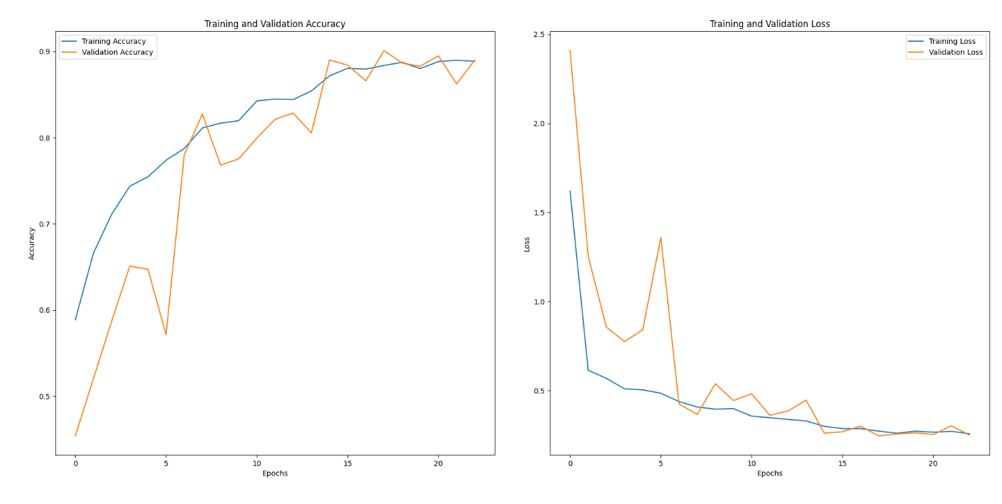

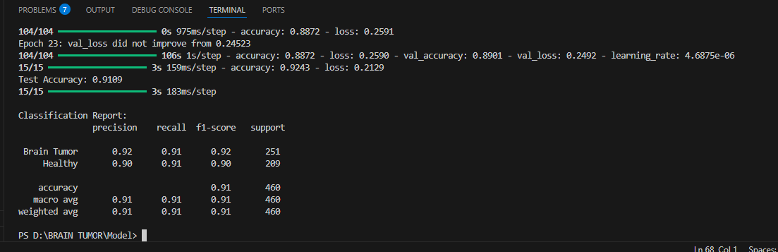

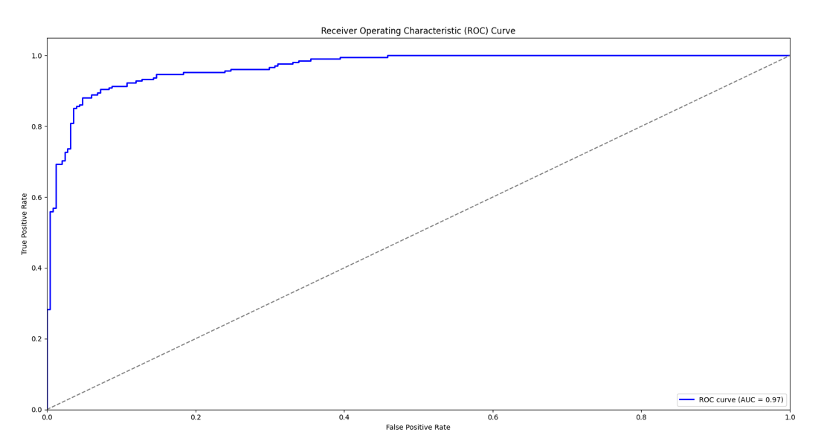
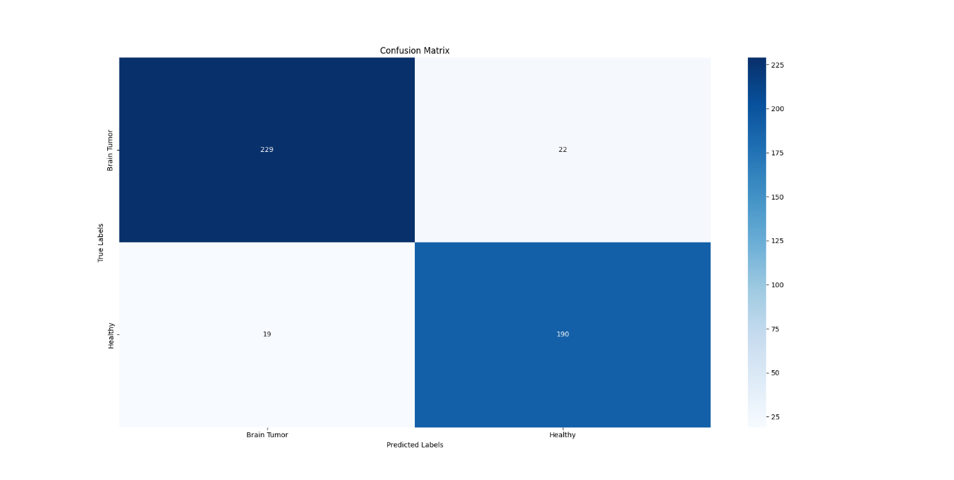
2)DNN Model:

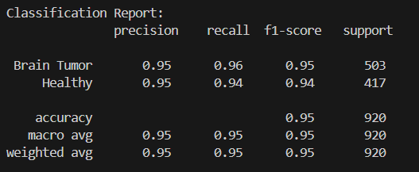

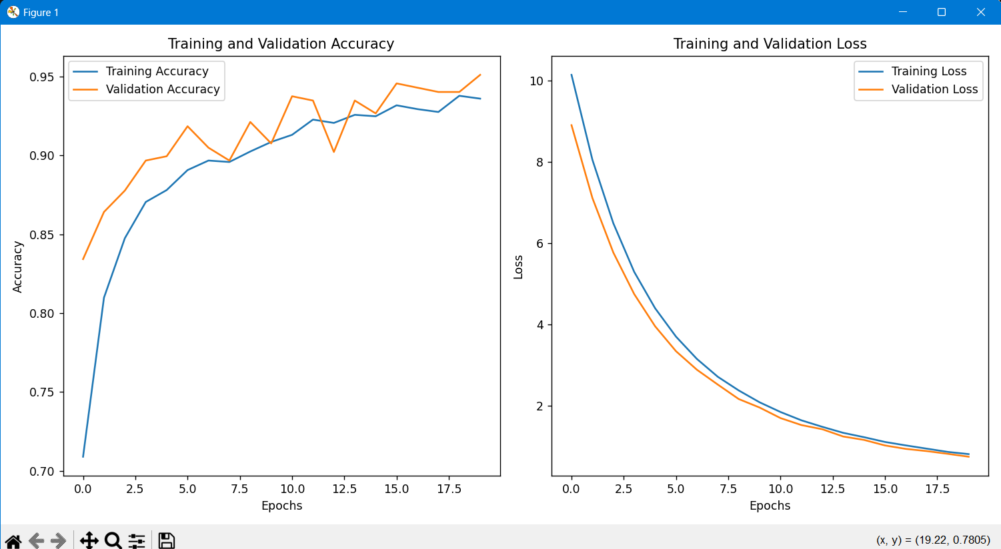
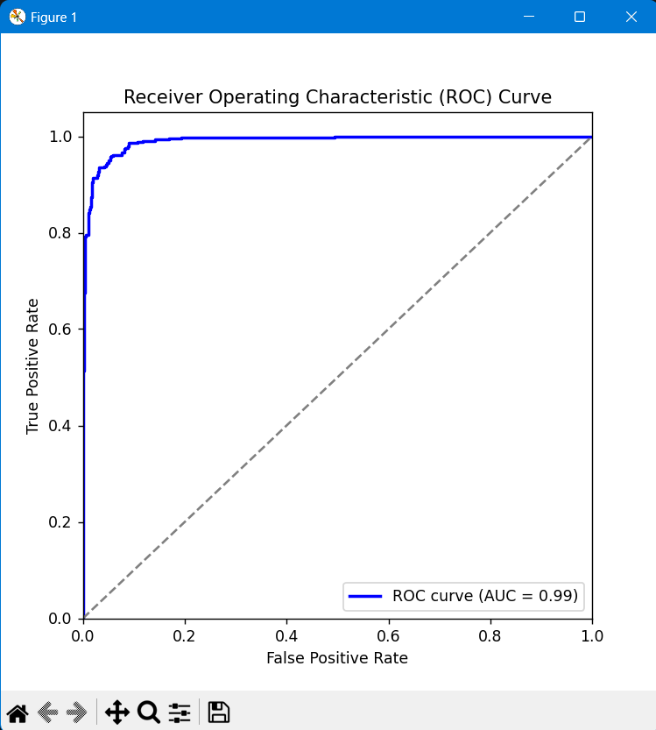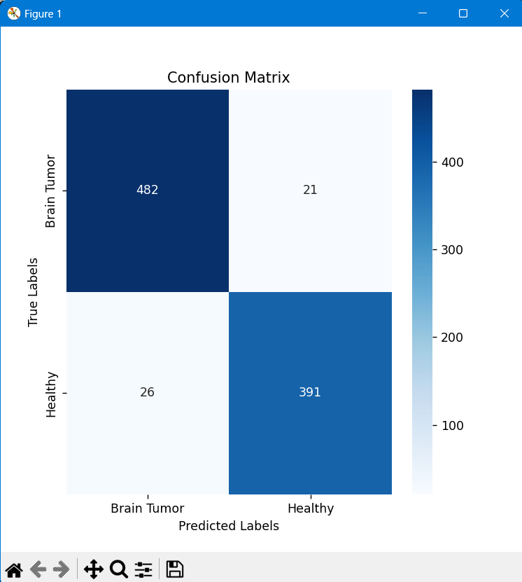

3)LSTM Model:

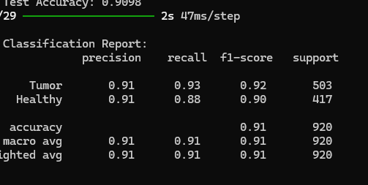

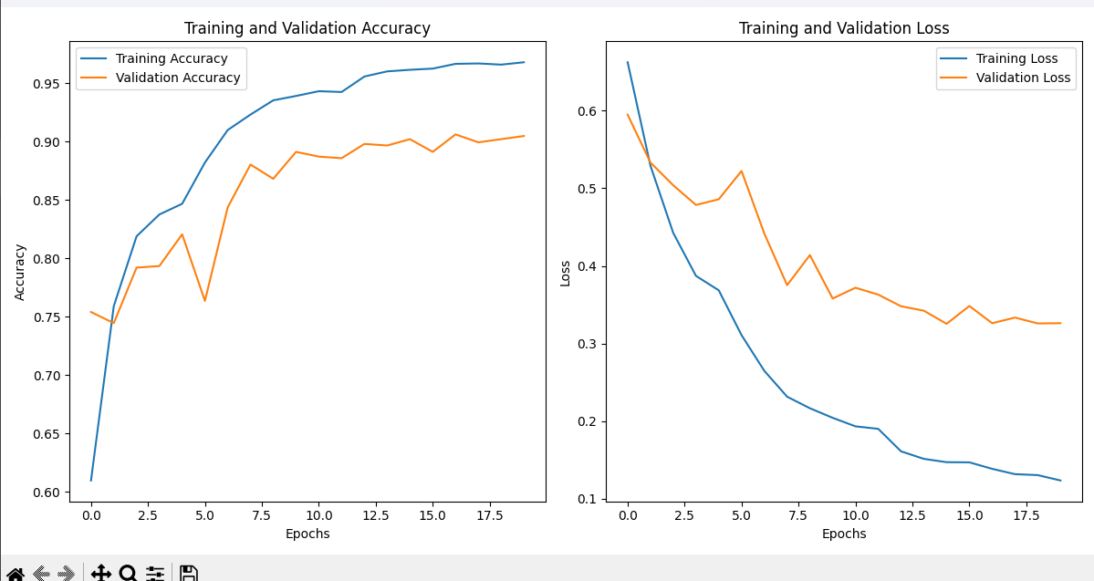
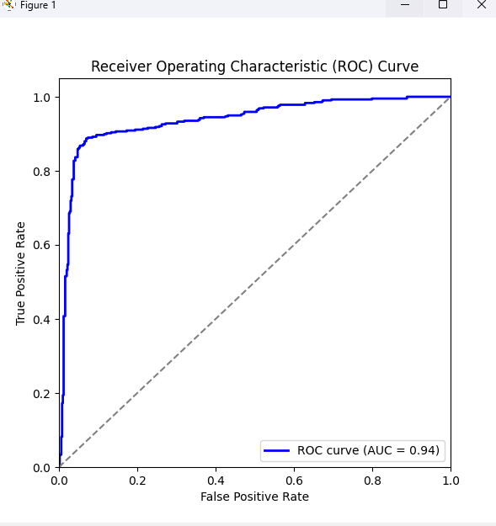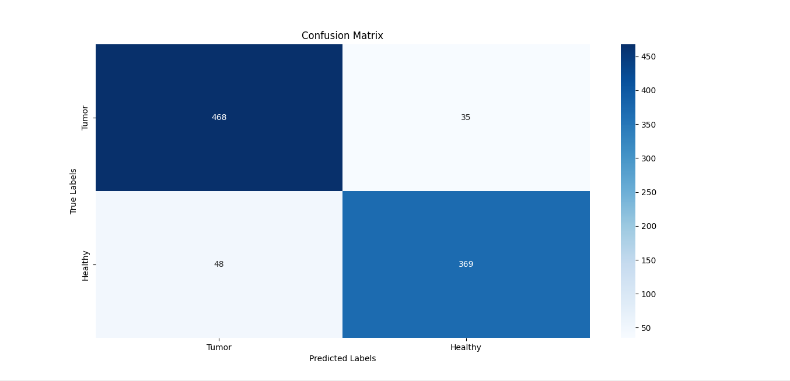
4) CNN+INCEPTION Model:

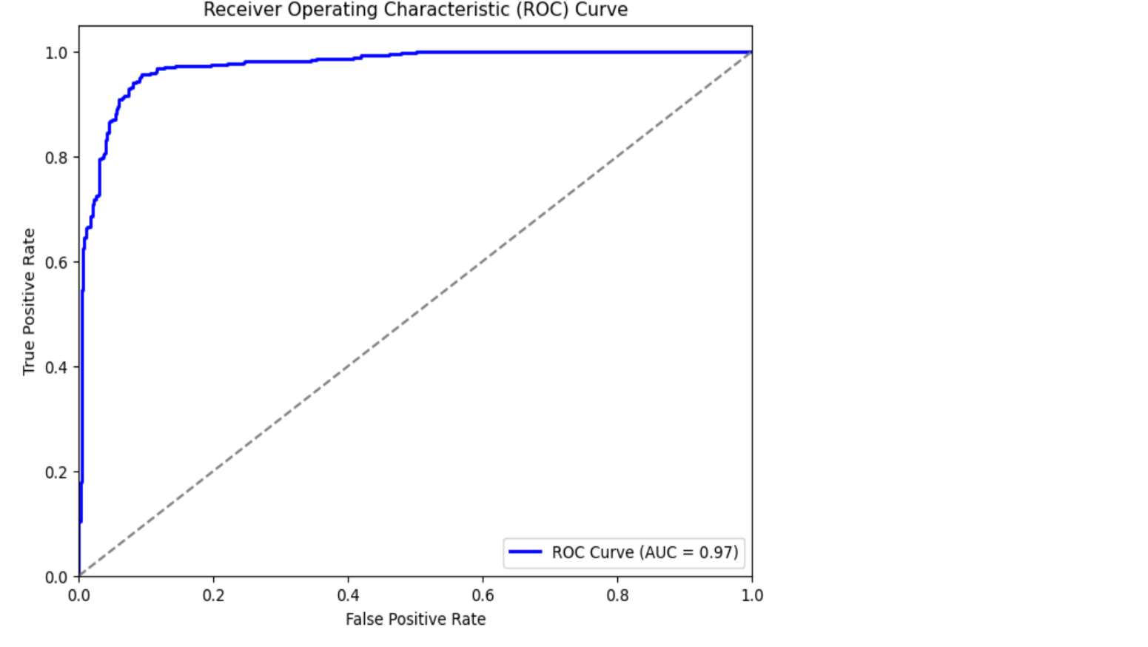

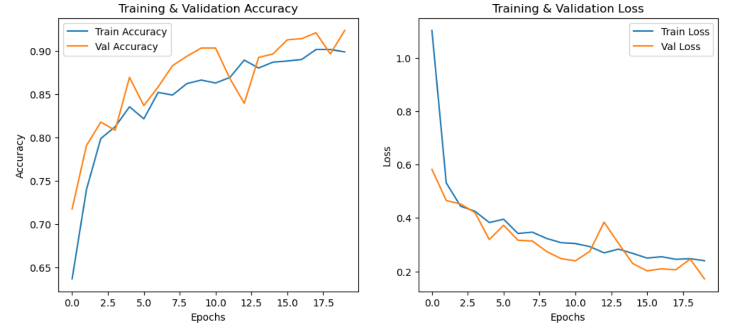
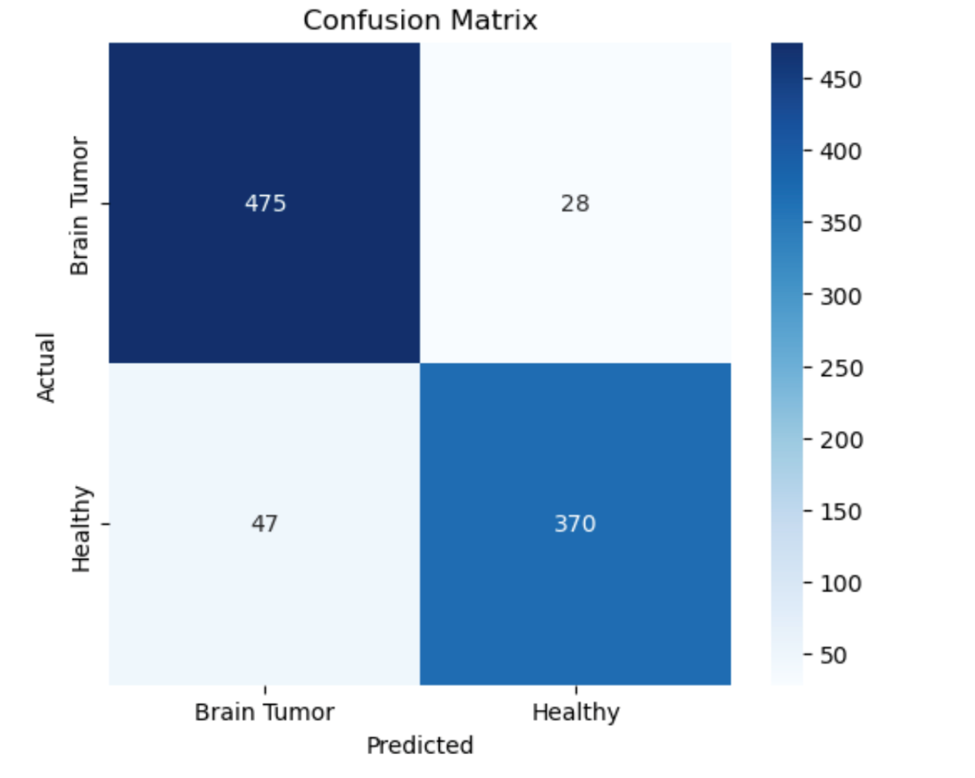
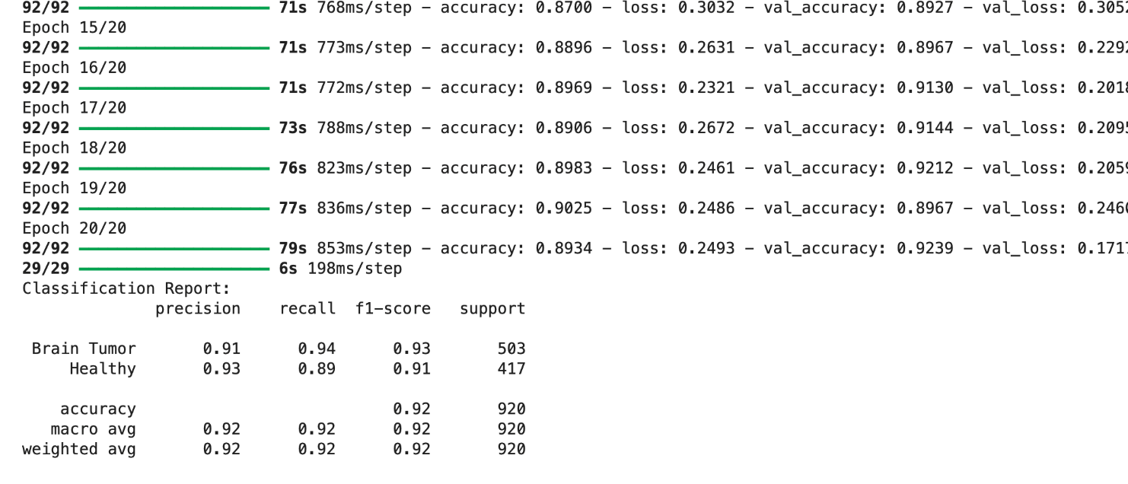
5) CNN+INCEPTION+ATTENTION Model:

